**I. Introduction**

**A. Background of the Problem**

MP Megapro Plus Marketing Corporation is a KTV Bar Restaurant in Jupiter St., Makati City which offers fine dining experience alongside with the entertainment provided by their karaokes. The establishment has two floors, with 6 rooms on each floor.One cashier has the only POS and it suffice the entire restaurant. There are 8 waiters waiting to serve the customers. The entire system of order taking of the restaurant causes problems like delays even though there are only few customers in the building.

**B. Statement of the Problem**

How to minimize delay time and meet the preferred service time of order taking from the client?

**C. Objectives**

● To decrease the waiting time of customers   
● To speed up the transactions of customer service   
● To identify the cause of delays in taking an order   
● To lessen the time it takes for the cycle of order taking to complete

**D. Significance**

The pattern of order taking will start with the customers elaborating their desired orders to the waiter,the waiter will write it in a paper, then the waiter will give the paper to the cashier,the cashier will then register the order in the POS machine,then the cashier will give it to the cook and the cook making the food for the customer and the waiter will served it to the customer. The project can be useful for restaurants that encounter delays from the moment the waiter records the order ,the cashier registers the order to the POS machine or to the time where he/she will handle it to the cook, due to various reasons such as staff incompetence, structural limitations and unusual large number of customers. With the project aiming to improve customer service, it will be beneficial for restaurants and alike.

**E. Scope and Limitations**

The study will just evolve around the MP Megapro KTV Bar and Restaurant, only focusing on the order taking part of their daily order taking operations. The time given to the students to come up with a solution to the stated problem is one year.

**F. Context Diagram**

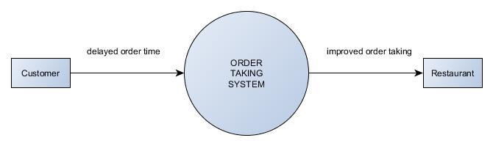

**II. Related Literature**

1. **Customer satisfaction in the restaurant industry: An examination of the transaction-specific model**   
Article in Journal of Services marketing · December 2005 By: Syed Saad Andaleeb and Carolyn Conway <https://www.researchgate.net/publication/241729526>

A research focused on knowing which factor must be best prioritized in ensuring high customer satisfaction. The research concluded that the responsiveness of frontline employees are essential in ensuring the happiness of a customer. This research is relevant on our problem because we are trying to address the problem of responsiveness in order taking.

2. **Are highly satisfied restaurant customers really different? A quality perception perspective.**   
By: Young Namkung and SooCheong (Shawn) Jang www.emeraldinsight.com/0959-6119.htm

This research is similar to the first above. Even though with the same topic, the research found that satisfaction relies from the presentation of the restaurants like its seating arrangement, smooth background music, etc. The responsiveness of the employees came last, but still considered as an important attribute of customer satisfaction.

3. **Singapore Mobile App ordering for restaurants, cafes, bars.**   
<http://bigspoon.sg/>

Our reference of the project. Bigspoon Singapore is a mobile app that acts as the ordering menu of the customer. With this in hand, the phone will be able to detect which restaurant is he/she in and formulate menus from the said restaurant.

4. **Eatsa Restaurant**   
<https://www.eatsa.com/>

The Eatsa restaurant uses a technology that quickens the transaction of ordering. The eatsa restaurant has a nine tablets stands which costumers can navigate and from their,the customers will choose the food that they like and it will instantly be seen by the cook thru a screen. The cook will put it in a drop out box and the customer will get it from there.

5. **OTG at Newark**   
<http://otgmanagement.com/>

The OTG at Newark is a fine dining restaurant within an airport. The technology that the restaurant uses is a tablet that is attached in a table. It will serve as the menu for the customers. No need for them to call a waiter or give their order to the waiter. They will just simply click the food that they want to be it and the cook will see it thru a screen and the order will be automatically registered with their machine. The customer will just wait for the Food to be serve to him/her.

6. **Breadcrumb**   
<https://breadcrumb.com/> <https://www.entrepreneur.com/article/224332>

This flexible iPad app provides real-time views of tables, catalogs the menu by a selection's name or ingredients, processes sales and delivery tickets and sends orders to the kitchen.: New eateries or those looking to completely overhaul their operations would get the most value out of Breadcrumb because it is so comprehensive. But the app will also work with traditional receipt printers and cash drawers.

7. **McDonalds Create Your Taste**   
<https://mcdonalds.com.au/create-your-taste>

This a new technology by McDonals where a person can choose choose his/her preferred ingredients of a burger thru a big touch screen machine. The customer will navigate it and once the customer decided what his/her final ingredients will be,he/she will click a button that will send it to the cook thru a screen. Allowing the cook to know the ingredients that will be used for the certain dish. The machine register the order and will give the user a receipt to show at the counter and the user will pay the needed amount their.

**General DFD For Related Literature**

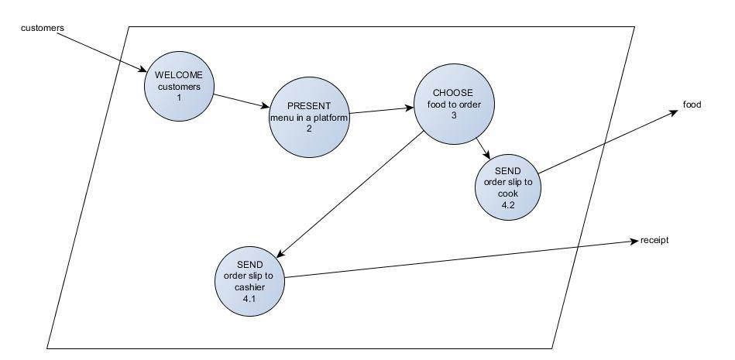

**III. Theoretical Background**

Comparing the processes involved in the current system of our client and the emerging new technologies by other competitors, there has been a clear indication on why the new technologies are better than the current system. In the current system, when someone ordered a food, it must be passed first through the cashier, needs it to be encoded before handing it over to the cook for the preparation of the food. On the other hand, the new technology promotes unification between the two entity, when someone ordered a food, the details will be transferred onto the cashier and also the cook at the same given time. With this kind of integration, the minutes wasted from the cashier handling the order slip to the cook will be eliminated, thus having a short time to deliver the food to the customer. The other advantage of advanced restaurants is that they promote customer satisfaction by letting them order by themselves without the interference of the waiter, that's why ordering platforms like tablets and touchpads are being deployed in tables for customer use.

**IV. Proposed Solution to the Problem**

**V. Results and Discussions, includes theoretical proof, verification,or eveidence**

**VI. Conclusions and Recommendations**

**VII.Appendices**

**A. Flowchart**

**B. Context Diagram**

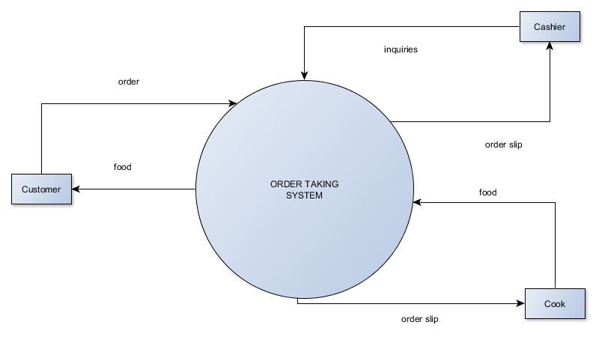

**DFD**

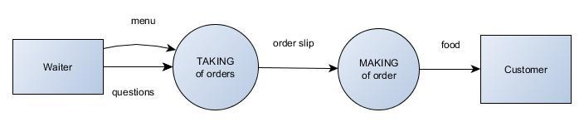

**Diagram 0**

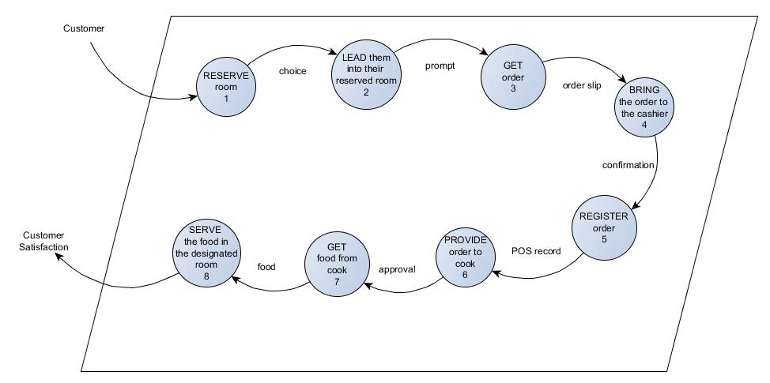

**Diagram 1**

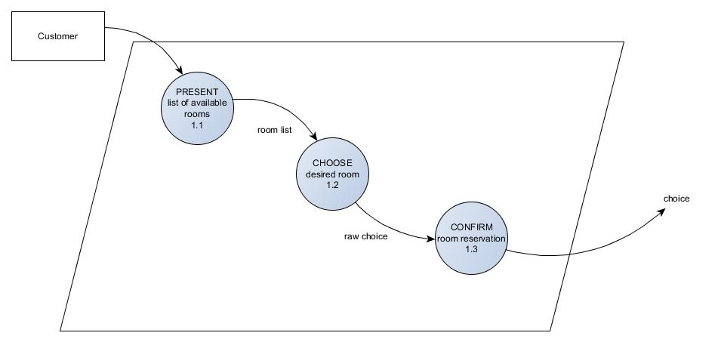

**Diagram 2**

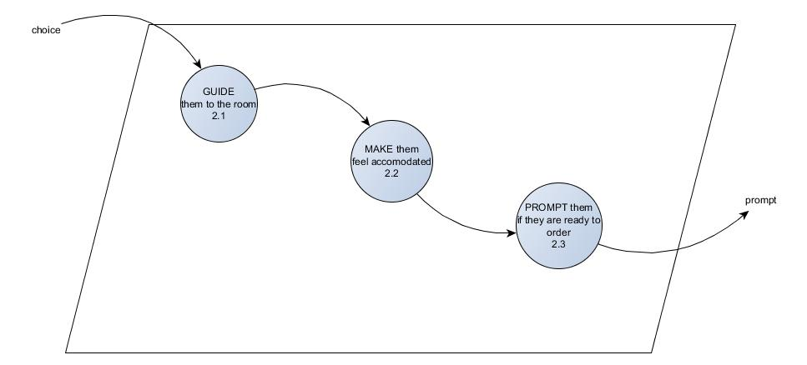

**Diagram 3**

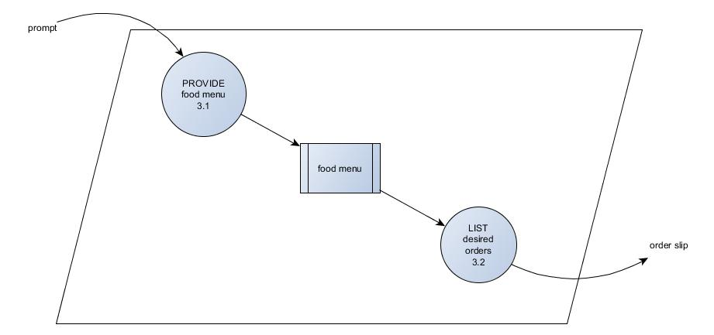

**Diagram 5**

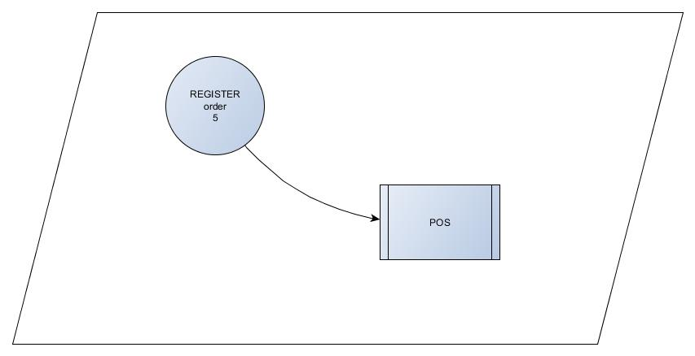

[[edit](http://projects2.apc.edu.ph/wiki/index.php?title=Project_-_Utilizing_Technology_To_Improve_Customer_Service&action=edit&section=28)]

**C. Entity-Relationship Diagram**

